THE CHOSEN, Matthew 4:24
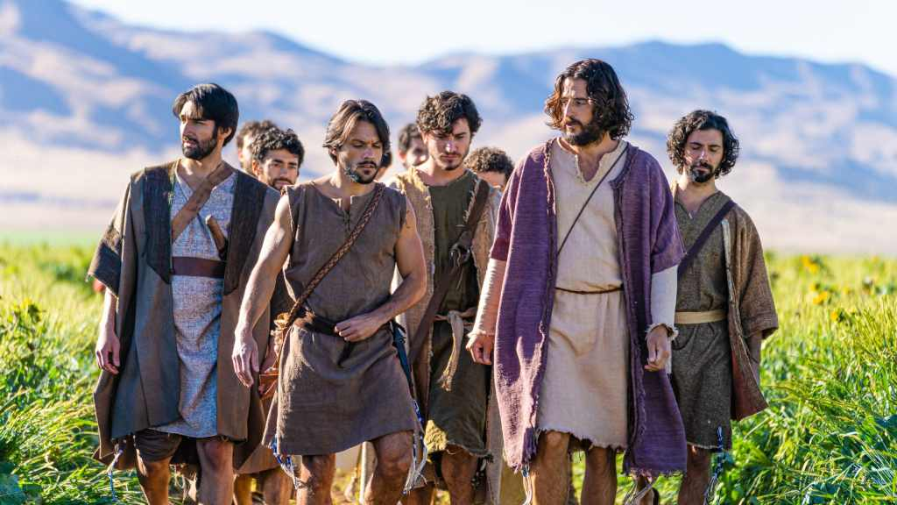
This week’s lesson is from Season 2, Episode 3, entitled Matthew 4:24. The story is based on Jesus busy ministry of performing miracles as recorded in Matthew 4:23-25.
The episode centers on the discussions between the disciples back at the camp around the campfire while Jesus was away. What were some of the topics they were discussing??
Does the heated arguing among the disciples seem plausible? For the Biblical data on the disciples arguing see Mark 9:33-37, Luke 22:24-27.
What thoughts did you have when Jesus returned from healing people and retired for the night? How did the disciples who had been arguing react?
Share any thoughts, comments, or questions in the reply box below. Join us Wednesday August 16 in person or online for a review of this material.

