THE CHOSEN, I SAW YOU
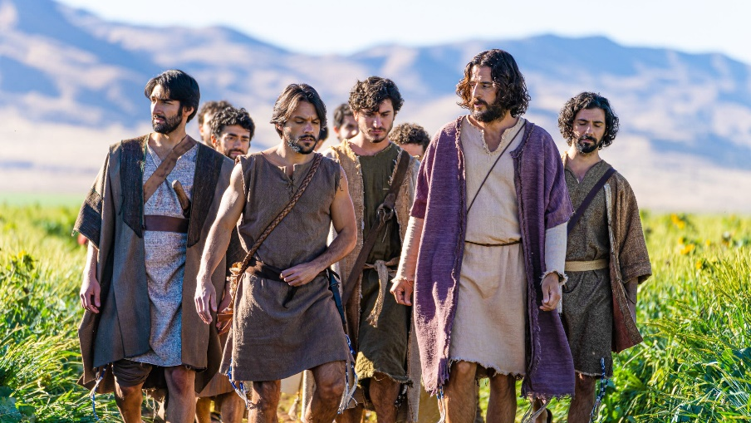
This week’s lesson is from Season 2 Episode 2, entitled “I Saw You”. The title comes from Jesus’s statement that He saw Nathanael under a fig tree and the main theme of this episode is the call of Nathanael.
The Biblical text on which it is based is John 1:43-51.
One theme that is brought out in this episode is that of learning torah / learning scriptures.
When in the episode did the disciples spontaneously quote scripture and what scriptures do they quote?
What shows the reverence and dedication the disciples had towed the scriptures?
We know very little of Philip from the Bible. How does The Chosen present his character?
What, according to the series, was Nathanael’s former occupation? How did he lose his job?
How does Jesus describe Nathanael?
Jesus told Nathanael he had seen him “under the fig tree”. What ideas have you had previously about what Nathanael was doing “under the fig tree”? What was Nathanael doing under the fig tree according to the Chosen?
One deeply thoughtful scene is the discussion between Philip and Jesus about death. How does it touch on the idea of Jesus struggling to prepare himself and everyone else for his coming death?
As Peter was a fisherman and would become a fisher of men. How would Nathanael “carry on” the same work he had previously when he becomes a follower Jesus?
Share any thoughts, comments, or questions you may have in the “reply” box below. Join us in person or online, Wednesday at 7 pm, for a discussion of this lesson.

