THE CHOSEN #1
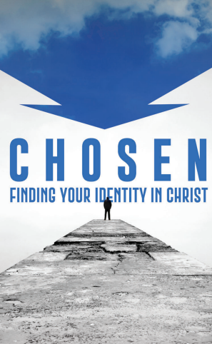
Season 1, Episode 1
I Have Called You By Name
The Chosen is about the surprising group of people who Jesus called to follow Him and be a part of the Messianic Kingdom.
Who are the chosen according to Ephesians 1:4 and 2 Thessalonians 2:13?
In episode 1 we are introduced to:
PETER
What was Peter’s occupation?
In The Chosen, what moral dilemma was Peter facing about his work?
For some indirect background on this issue study Matthew 12:1-7.
NICODEMUS
Who was Nicodemus? (John 3:1, 10)
How does the episode cause you to think of Nicodemus in new ways?
What is his stance on the moral dilemma Peter was struggling with (though they do not yet have contact with one another).
MATTHEW
What are your thoughts on how the show portrayed Matthew?
Why does Matthew go to great effort to hide himself going to and from work?
MARY MAGDALENE
What do we learn about Mary from Luke 8:1-2?
Imagine the life of someone possessed by 7 demons. It is commonly assumed that she was a prostitute but that is not stated. How does the show portray her condition? What efforts are made to overcome her condition?
In The Chosen, how is Jesus able to reach Mary?
Why was Isaiah 43:1 such a meaningful passage of scripture to Mary?
What does Isaiah 43 say to someone who is struggling with despair and discouragement?
Leave any thoughts or comments in the reply box below. Join us in person or on line Wednesday Jun 14 for a review of this material.

