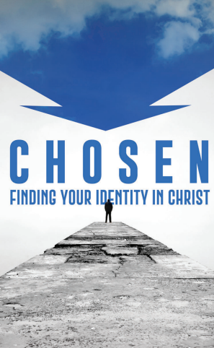
For this class watch The Chosen, Season 1, Episode 4.
The centerpiece of this episode is Peter’s miraculous catch of fish that is recorded in Luke 5:1-11.
Other story lines:
In this episode we are introduced to John the Baptist. Read about him in Luke 3:1-14. What did the disciples of Nicodemus say about the wilderness preacher? Why were they agitated by him?
One of their complaints was “He called us snakes” to which Nicodemus said, “what else?” to which they replied”, “what else? what can be worse than that?”. What was Nicodemus’s response?
What does Matthew tell Quintas about his relationship with his fellow Jews?
Who does Andrew tell Peter he has seen? (John 1:40-41). For the excitement that surrounded the Messiah see also verse 45.
Concerning the story of Peter. Remember how the series plays up the idea of financial pressure on Peter and his family. How would a night of “toiling all night and catching nothing” affect a fishing business and a man like Peter’s responsibility to provide for his family?
How is all of this affecting his relationship with his wife (this is an embellishment of the story certainly, but not at all far-fetched). What does Eden say he has done wrong?
What impressed you about the scene of the fishermen fishing at night on the Sea of Galilee? Did you learn anything new about what it might have been like to have been a fishermen in that day?
Do you think Jesus experienced any delight (as is portrayed in The Chosen), when He performed a miracle like the miraculous catch of fish?
Does it surprise you that “they forsook all and followed (Jesus)” (Luke 5:11) as soon as Jesus called them? How would the great catch have made that more difficult? How did it make it an easy decision?
Jesus made a spiritual application of the miracle: “Fish are nothing, you have much bigger things ahead of you Simon son of Jonah. From now on I will make you fishers of men”.
There may be an issue with the title of this episode: “The Rock On Which It Is Built”. To what was Jesus referring when He said “On this rock I will build my church”? See Matthew 16:16-18 and compare Ephesians 2:20, Matthew 21:42 and John 1:42.
Share any thoughts you have in the reply box below. Join us in person or on Facebook Live for a review of this material Wednesday June 28 at 7 pm.

