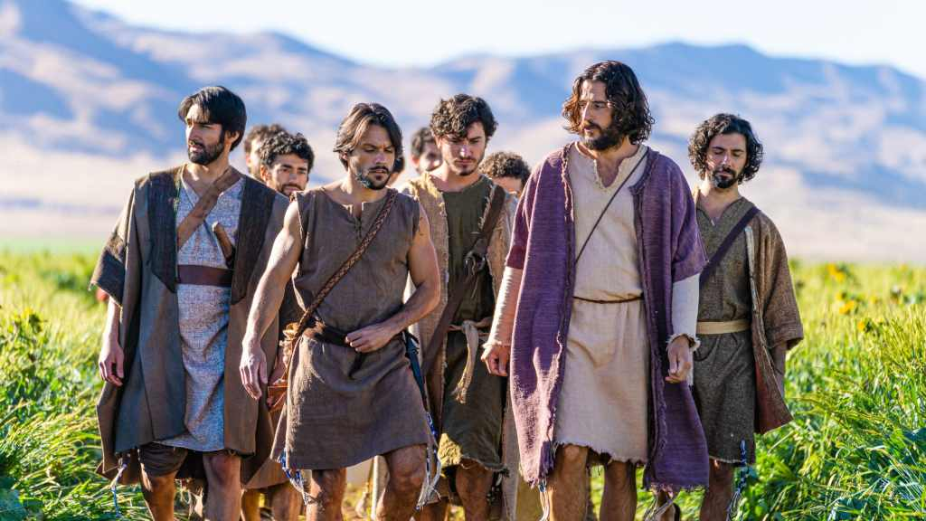
For this class watch season 2, episode 7 of the Chosen, entitled Rekoning.
The main theme in this week’s lesson is Jesus being detained by the Romans for questioning and how the disciples react to His detainment.
Lesser themes in the episode are Jesus preparation for the sermon on the mount and the Jewish investigations of Jesus led by a Pharisee named Shmuel.
Did you imagine Jesus preparing for the sermon on the mount (Matthew 5-7) to be as portrayed in the Chosen? If not, what is different about the way The Chosen presents it? At the end of the episode who does Jesus ask for help and how does this fit into the Biblical account?
Is there any record of Jesus being detained by the Romans early in His ministry?
Watch the presentation of his detainment and the questioning. What do you see in the demeanor of Jesus, His interactions with the Romans, and the dialog with Dominus that rings true to the Biblical accounts?
How did the disciples react? Again, does that seem like a reasonable portrayal of the disciples? What scripture does Mary Magdalene make reference to when saying they should trust Jesus?
Thank you for participating in our Bible study! Leave any thoughts or questions in the reply box below. Join us Wednesday night at 7 in person or online for a review of this material.

